# **Date of Submission: 9th Dec, 2022**

# 

# 

# **Database Project Report**

# **Online Food Ordering Website**

# **Group Members:**

# **(K200145) Muhammad Zunique**

# **(K200248) Ali Abdullah**

# **(K200283) Abdullah Memon**

**Section: BCS-5E**

**Course Instructors:**

* Miss Erum Shaheen
* Miss Zumar Noor

**Table of Content:**

* Introduction
* Technology used
* System Design
* Normalization of tables
* ER diagram
* Triggers
* Connectivity
* Project Snapshots

**Introduction:**

1. **Motivation**

The motivation for this project is to provide a convenient way for ordering food instead of having to communicate orally with the restaurant’s communication service which could pose many problems. This includes: customers needing a physical copy of the restaurant’s menu and having to place an order without receiving much feedback. This often results in confusion and incorrect orders. Due to these reasons we decided to construct an online food ordering system.

1. **Problem**

The project has been developed on java Script and PHP. The main purpose of this project is for a restaurant to sell orders and for a user to place them. The project intends to provide users with numerous food options which they can order depending on their need. After which the requirements of the order will be communicated to the restaurant and will be delivered. We need to ensure that the orders accepted are delivered to the user and the information of the order selected is correct.

1. **Solution**

Admins help solve this problem. The categories inputted will be hard-coded by the admin from which the user will have to manually select an option in order to avoid any inconsistencies with the information place. Moreover, the delivery person (Food delivery boy) will send a confirmation once an order has been delivered.

**Technology Used:**

1. HTML
2. CSS
3. JavaScript
4. Bootstrap
5. PHP myAdmin
6. XAMPP
7. PHP (backend)

**System Design:**

**Admin Panel**

* Can keep track of orders ,order details ,payment status,etc
* Can add or Remove an admin and can also activate or block their status from website.
* Can Add Category
* Can Add or remove Dishes From Menu
* Can keep track of users and can block or activate their status
* Can keep track of delivery team.

**User Panel**

* Can View Order History
* Can Choose Dishes and their Quantity
* Can Add or Remove Item from Cart.
* Can Empty Cart
* Can View Cart
* Can place Order

**Delivery Panel**

* Can update order status once order delivered
* Can update payment status, once order delivered

**ER Diagram**

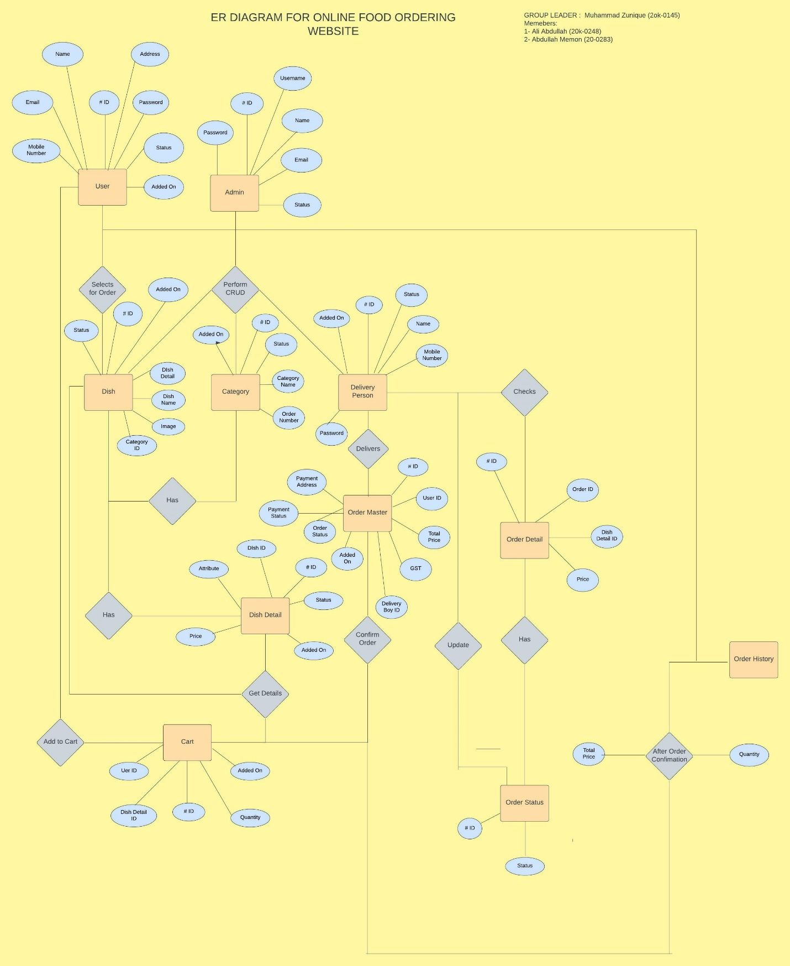

**Triggers**

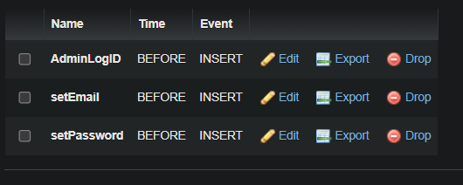

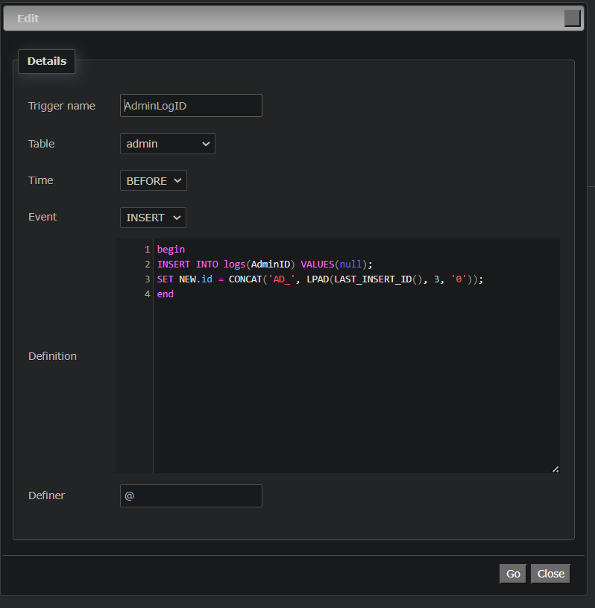

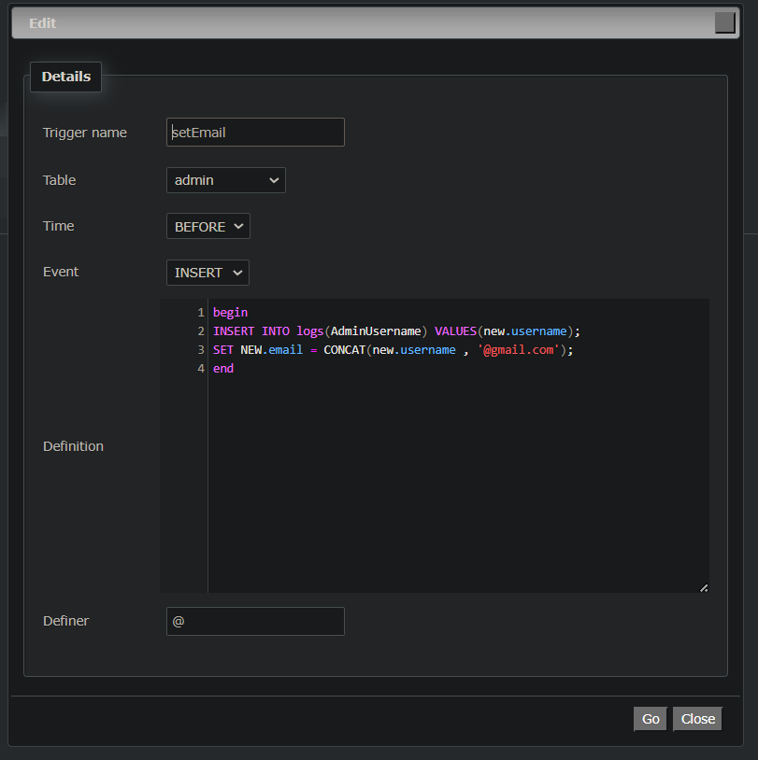

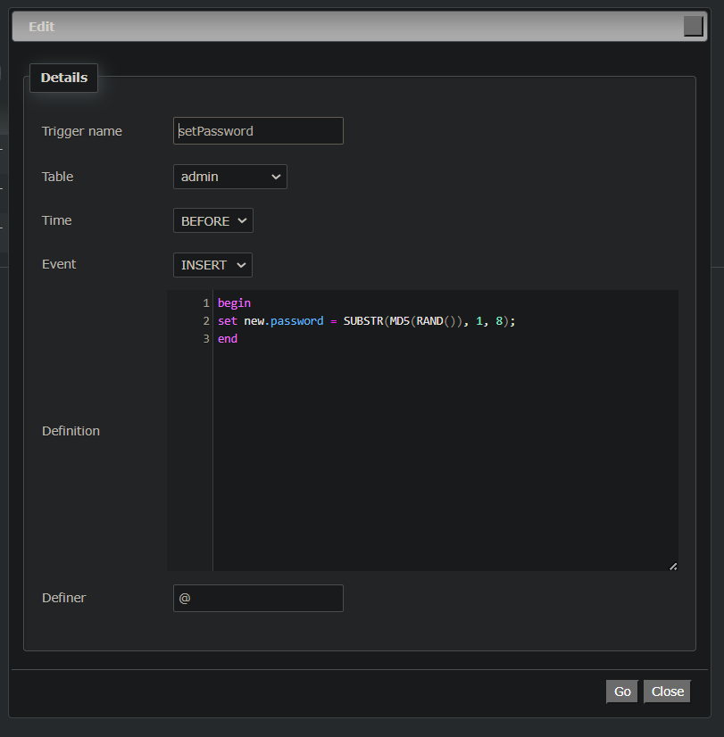

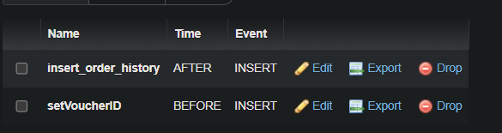

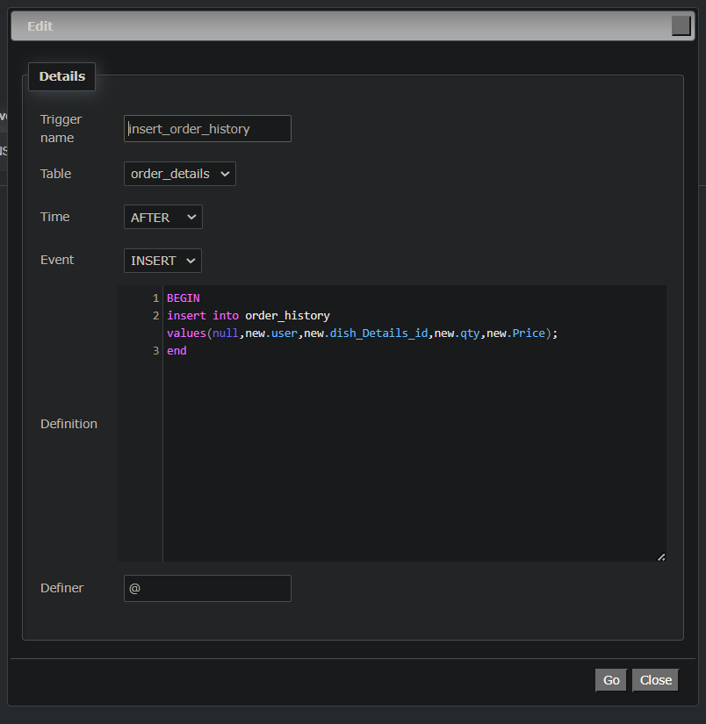

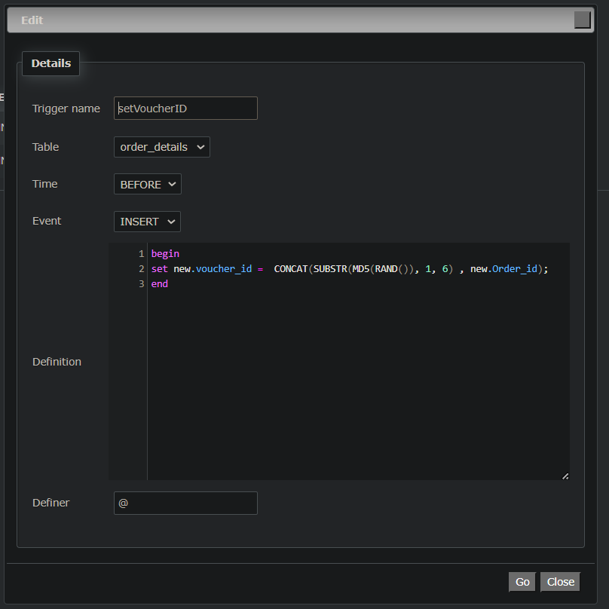

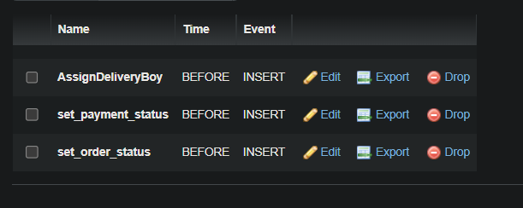

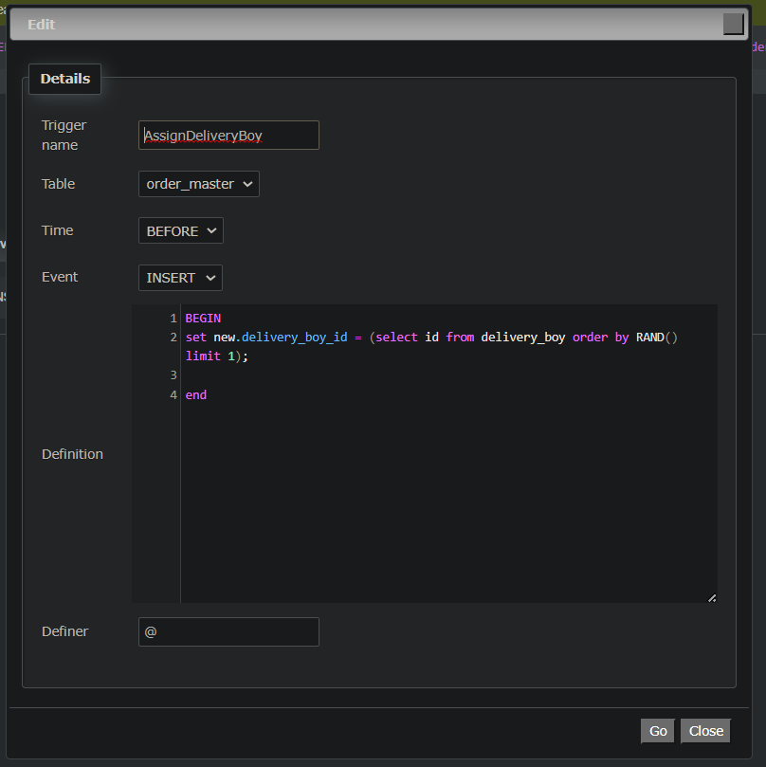

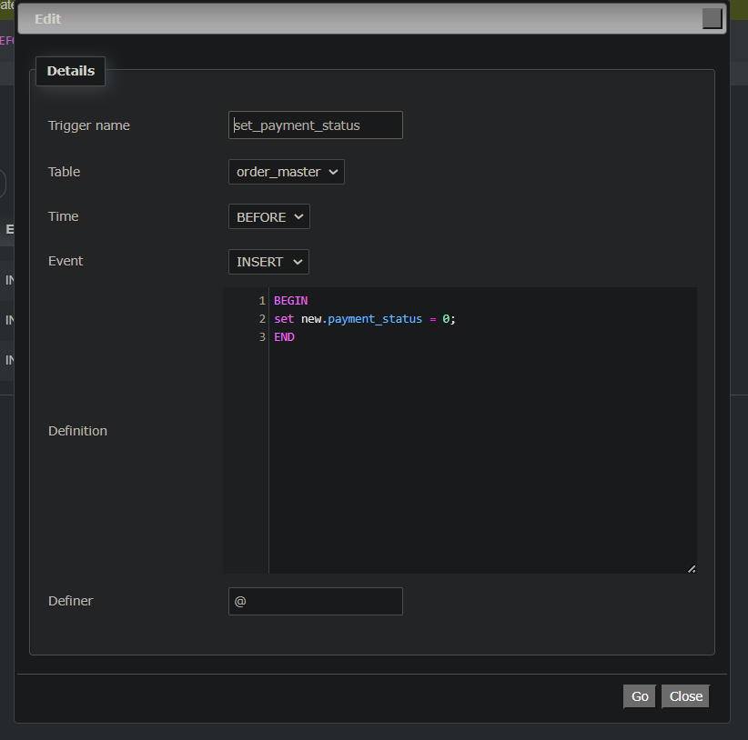

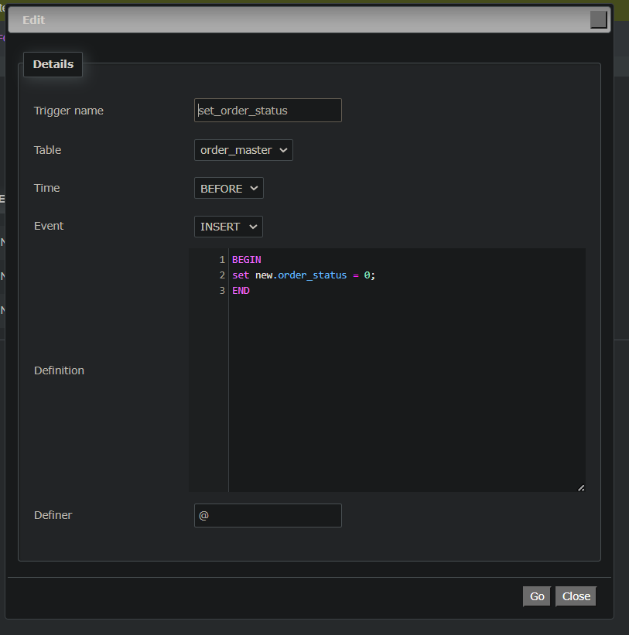

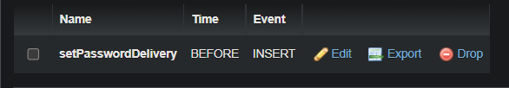

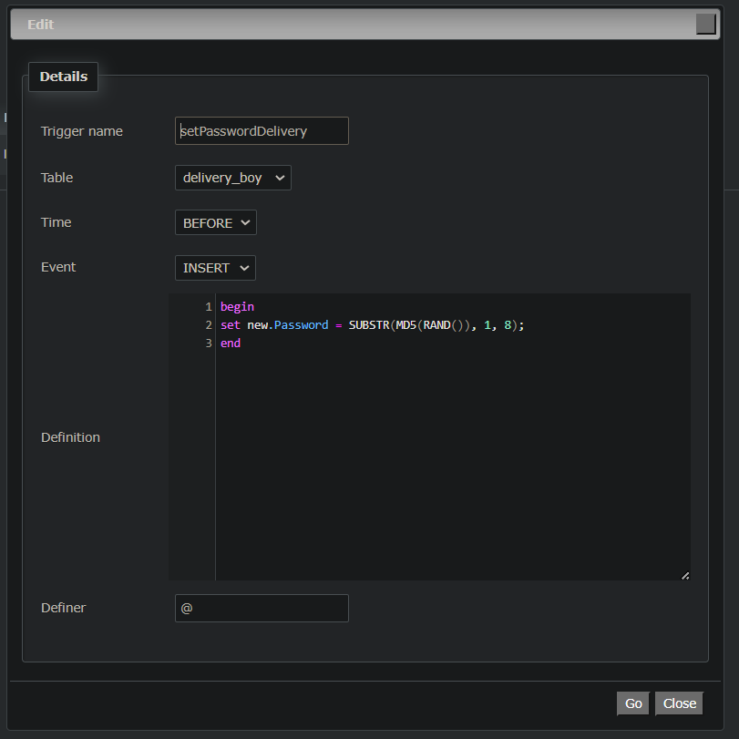

**Connectivity**

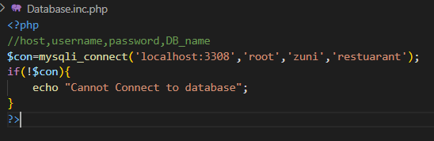

* Admin:

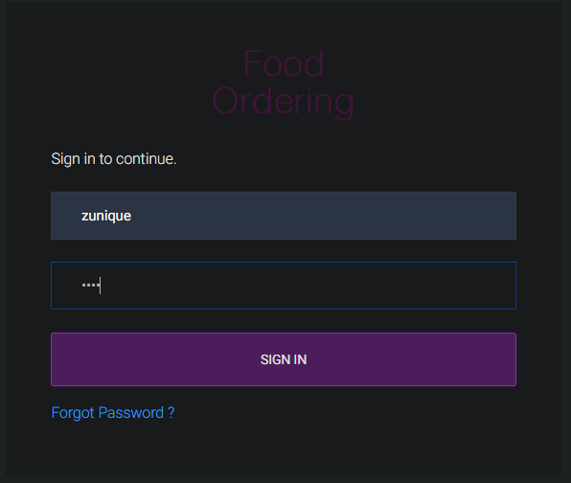 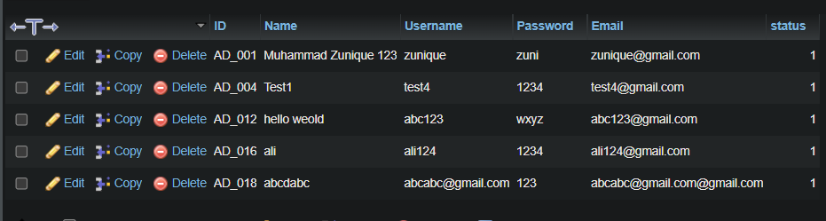

* User:

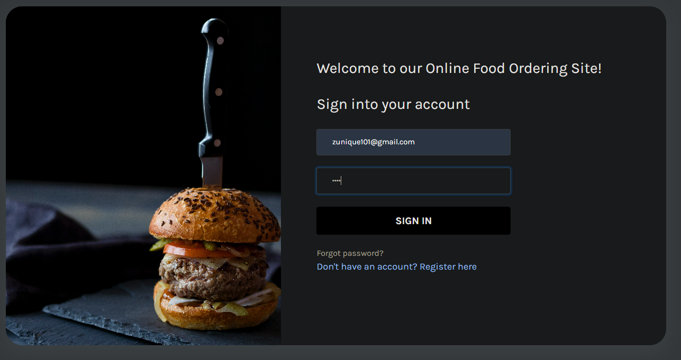

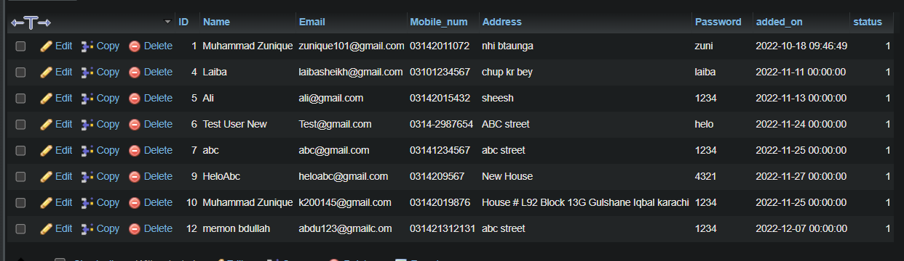

* Delivery Boy:

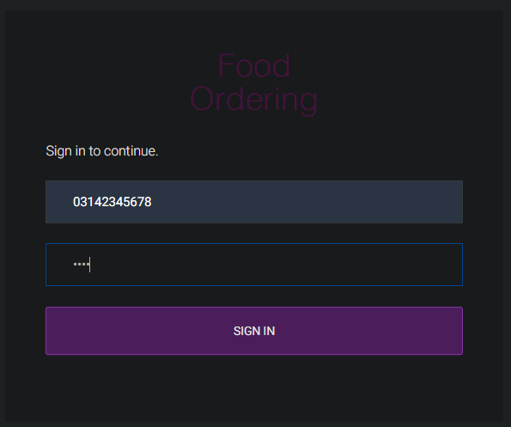

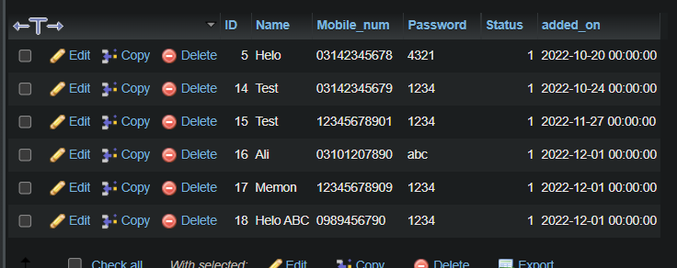

**Screenshot of Project**

* **Admin:**

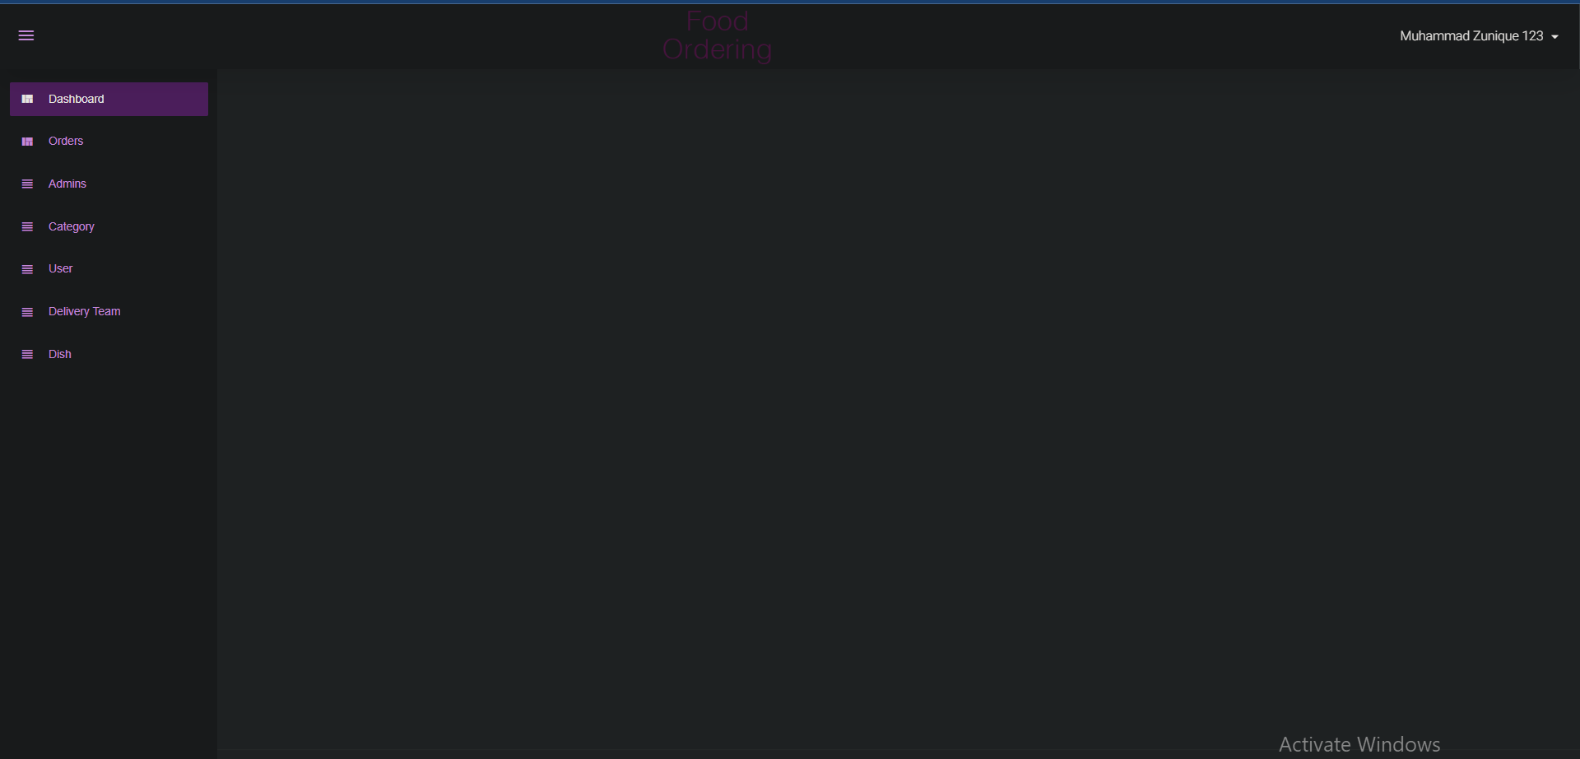

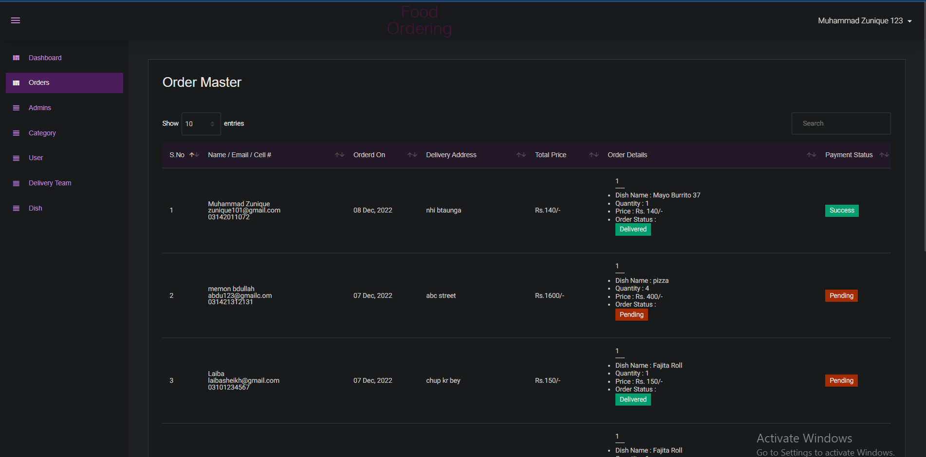

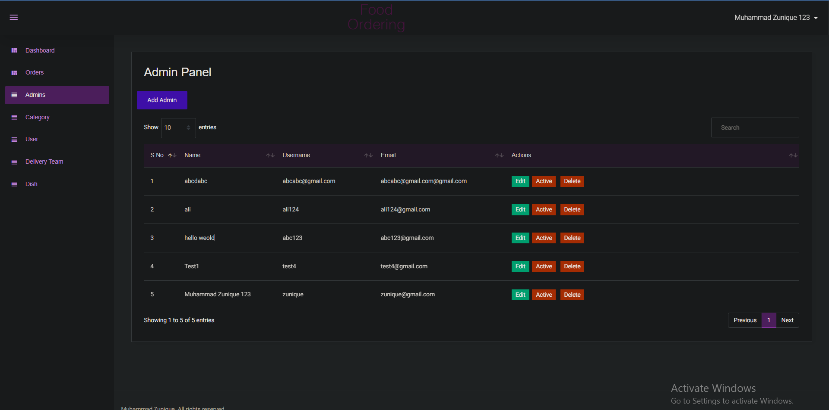

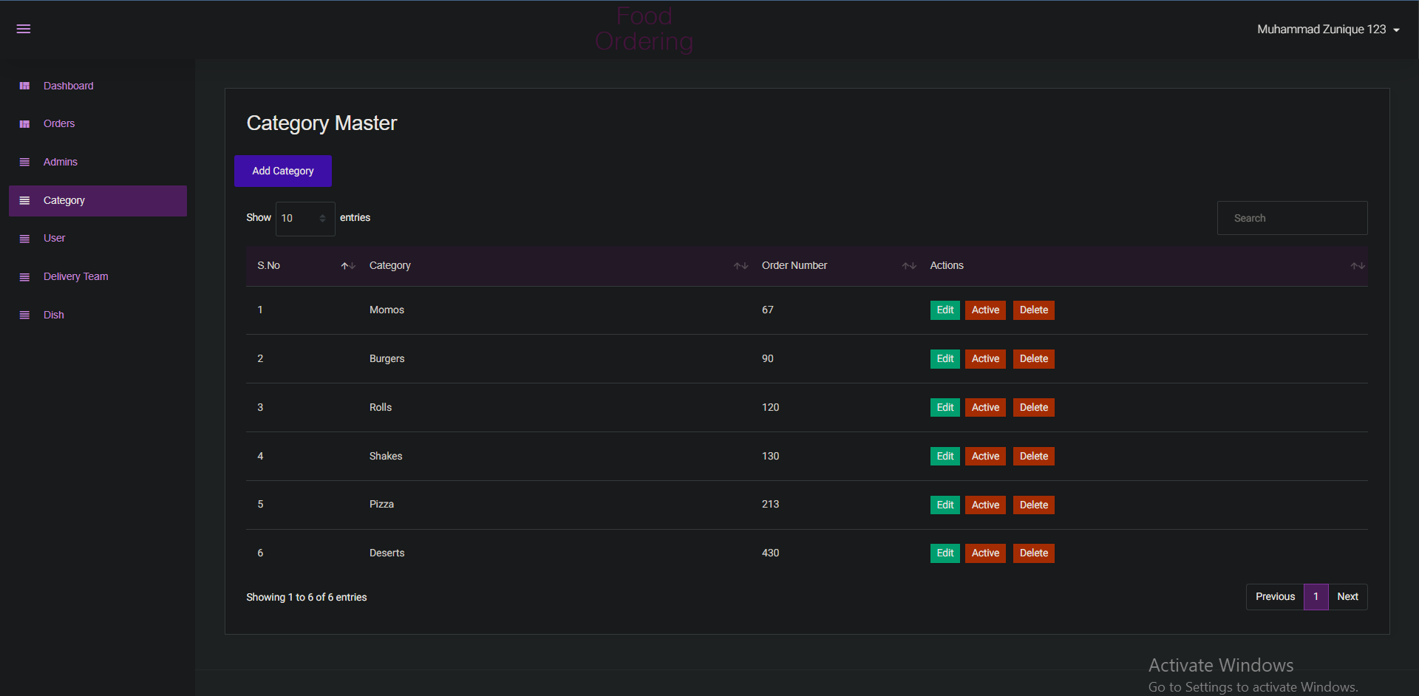

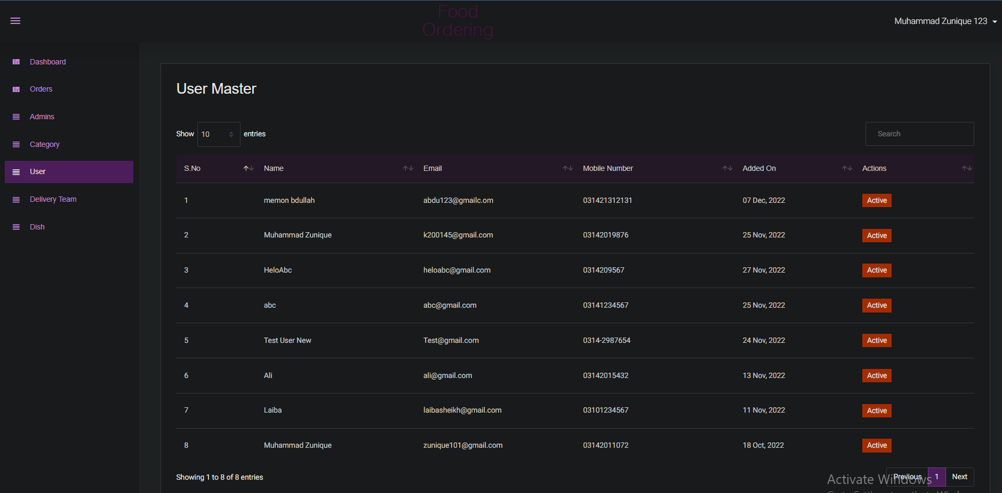

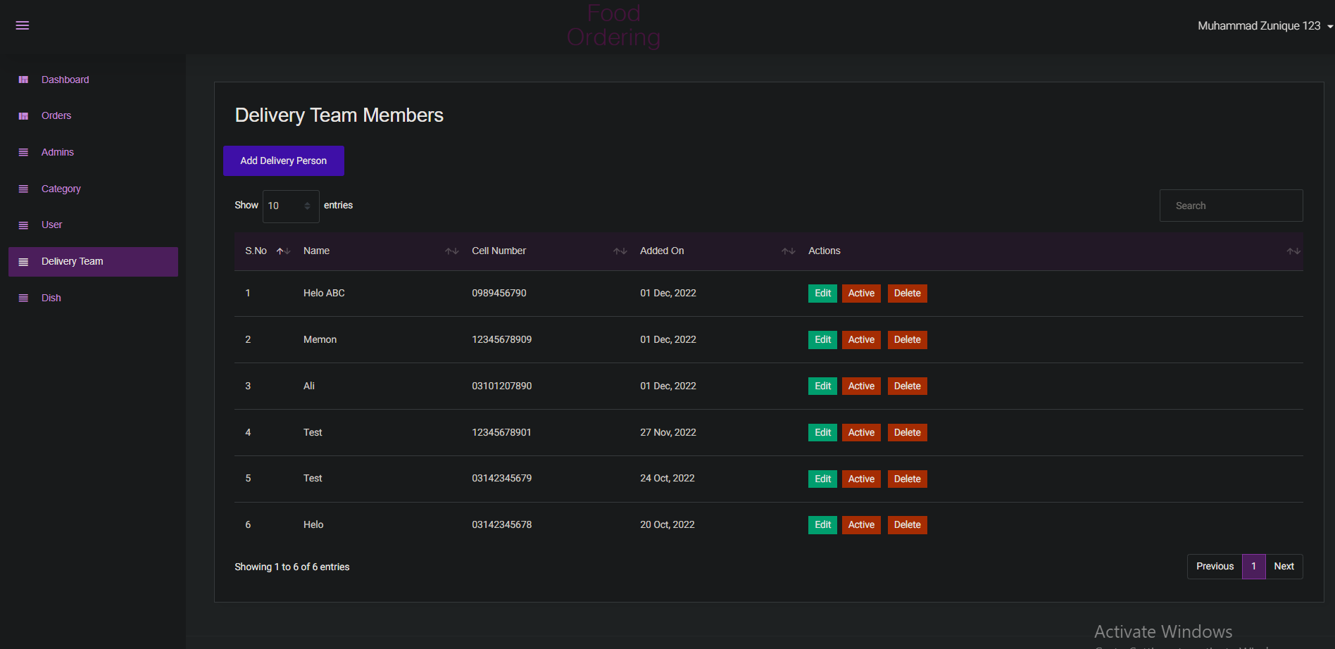

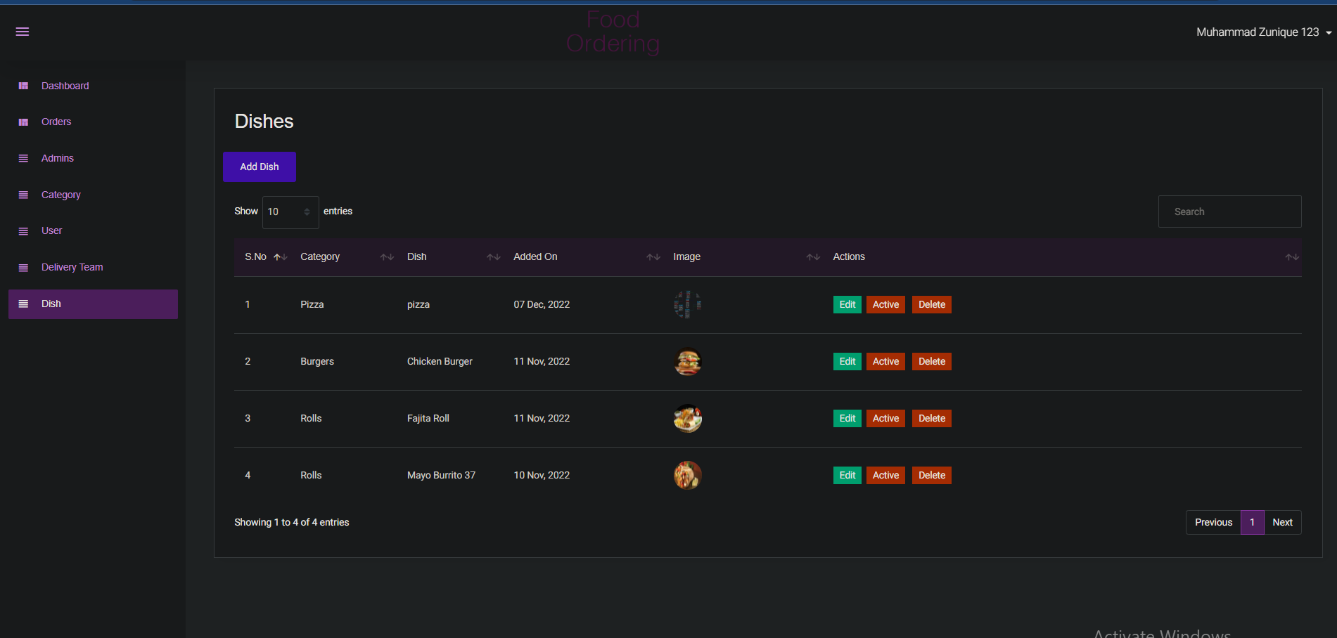

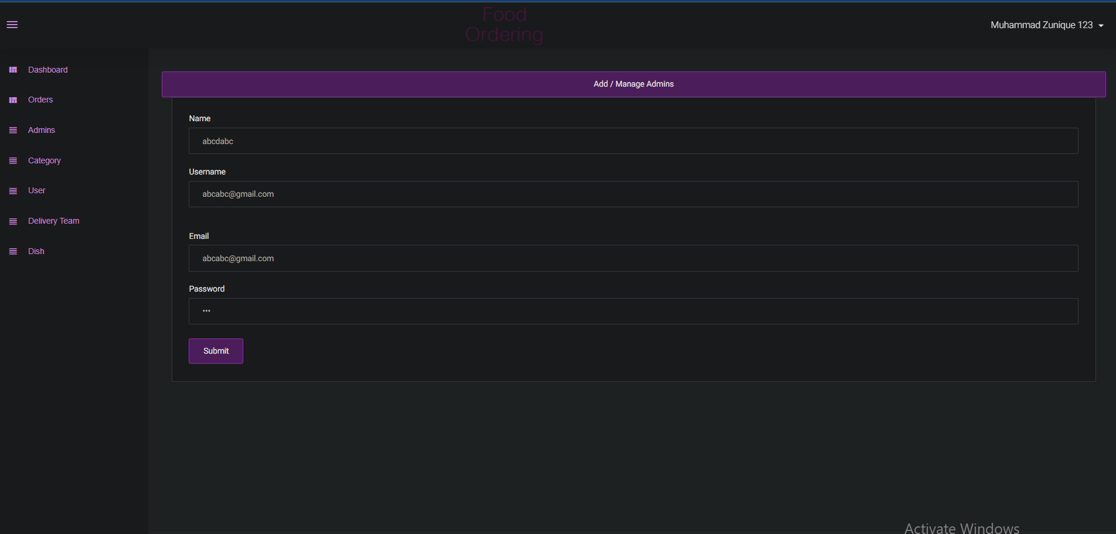

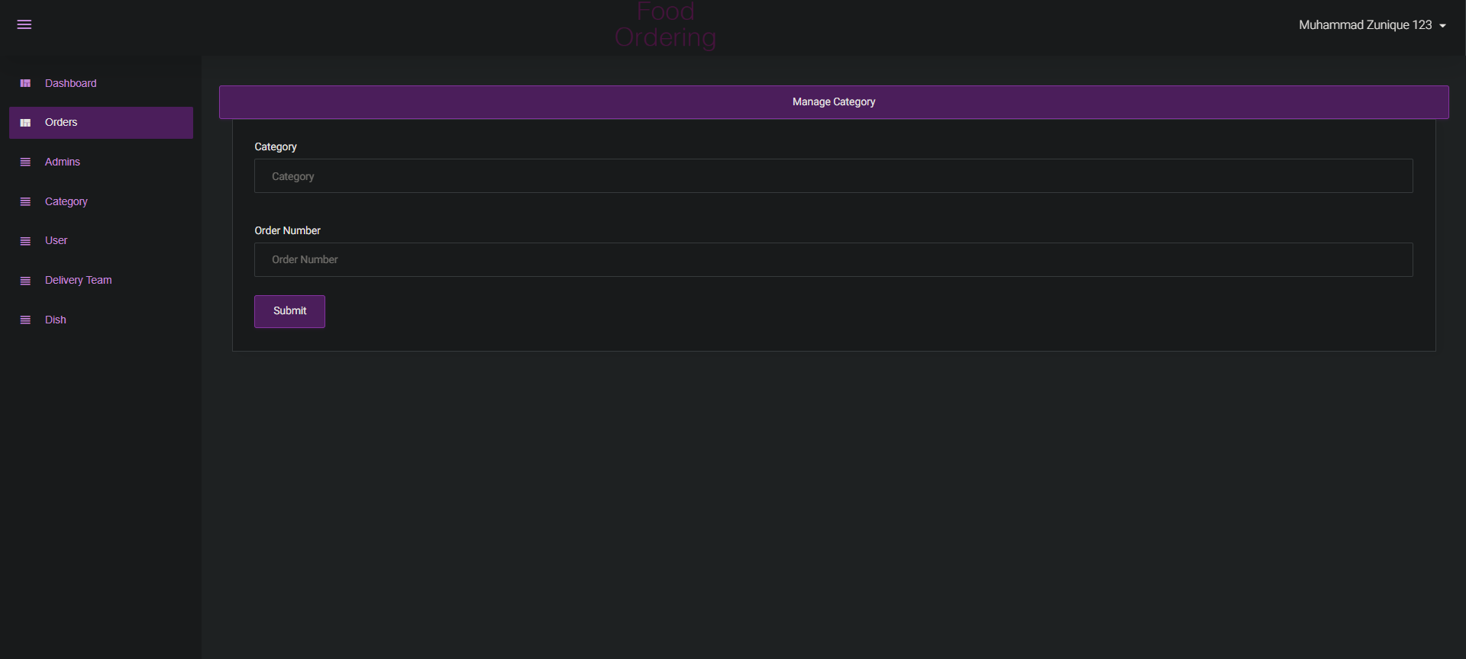

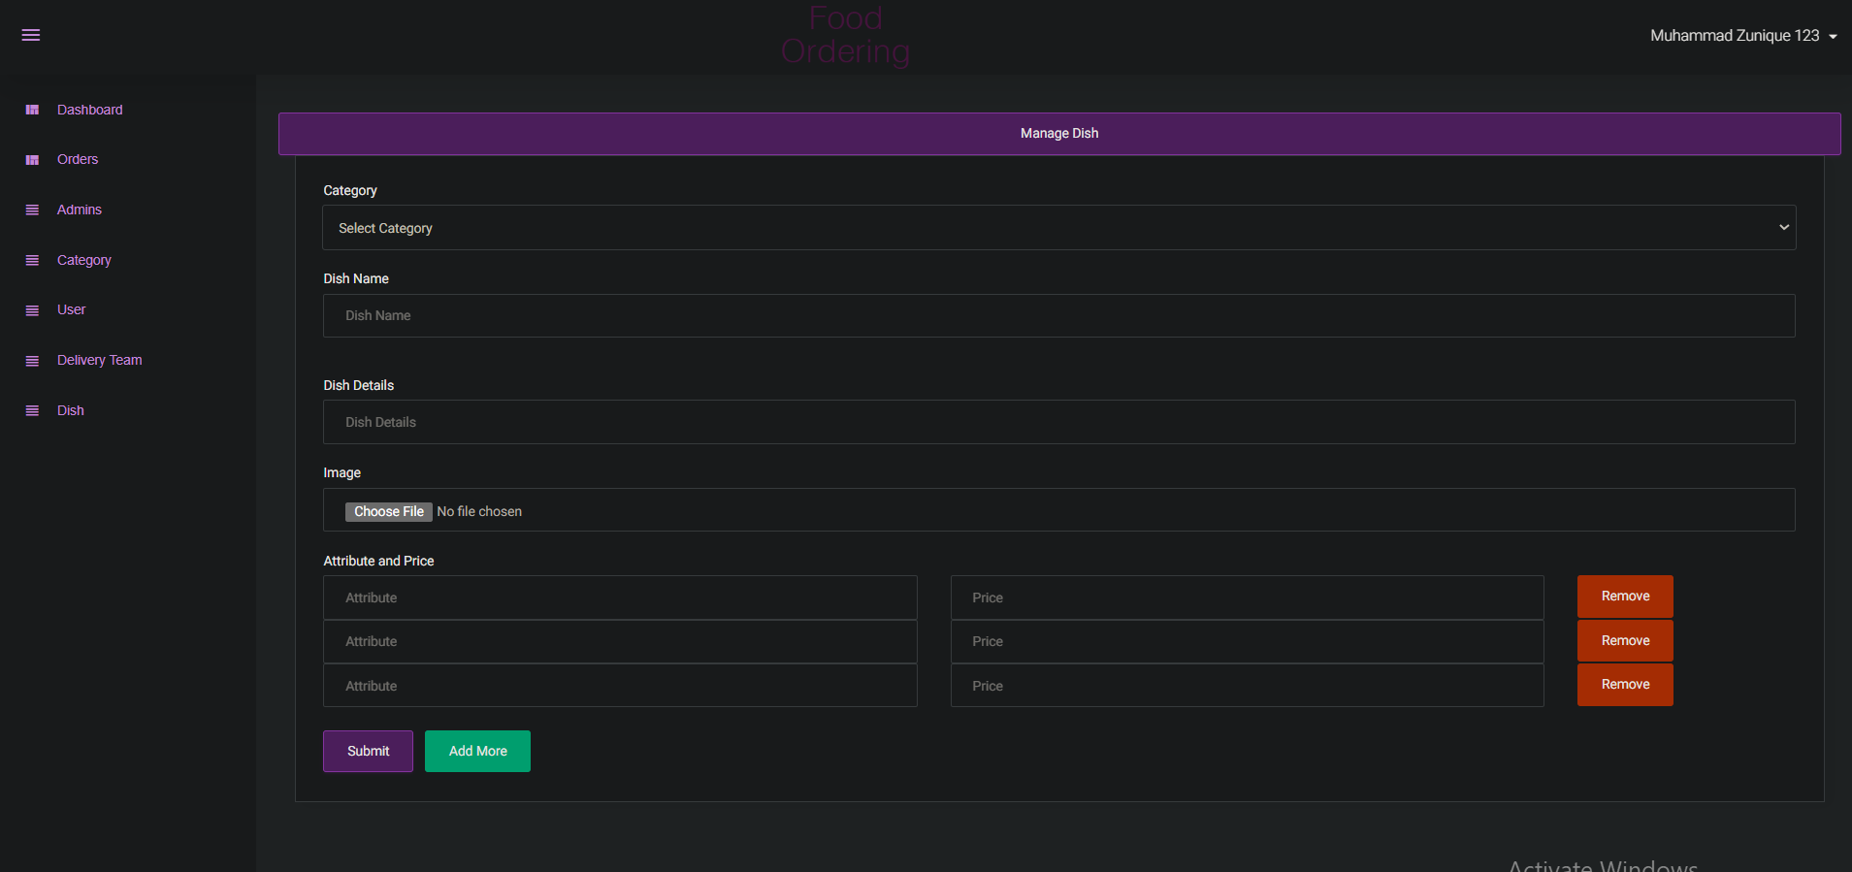

* **User**

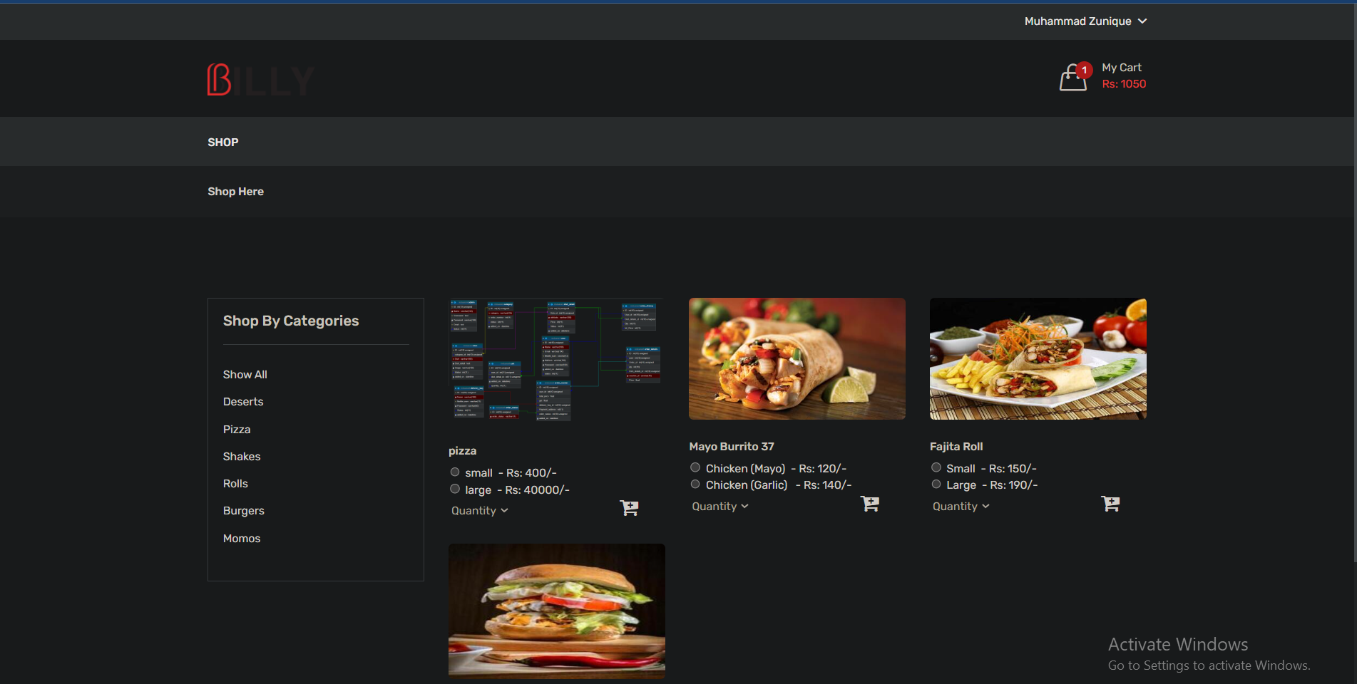

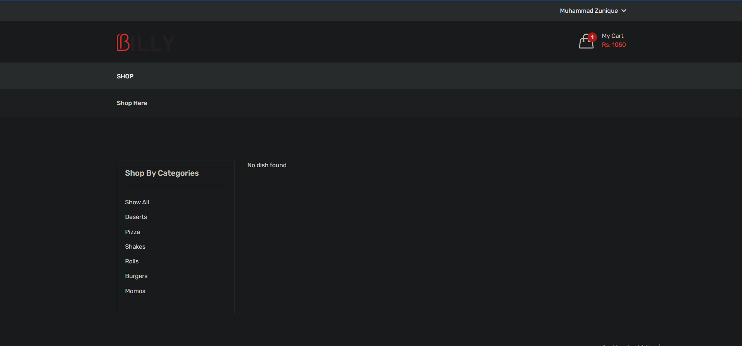

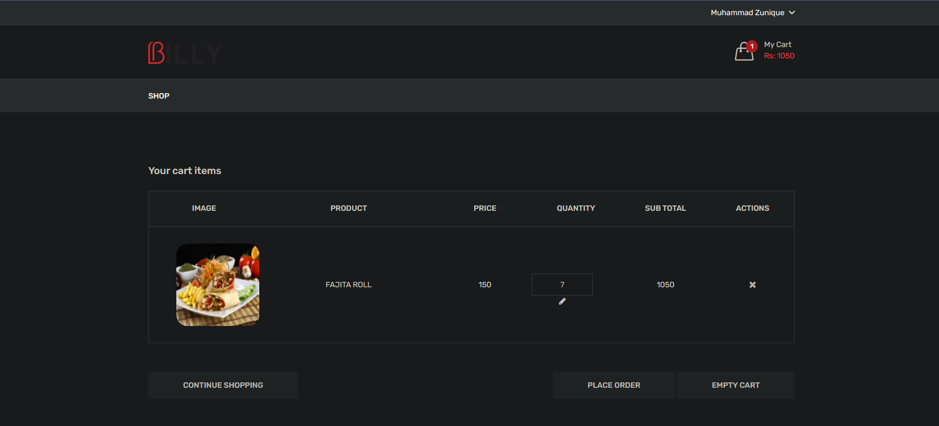

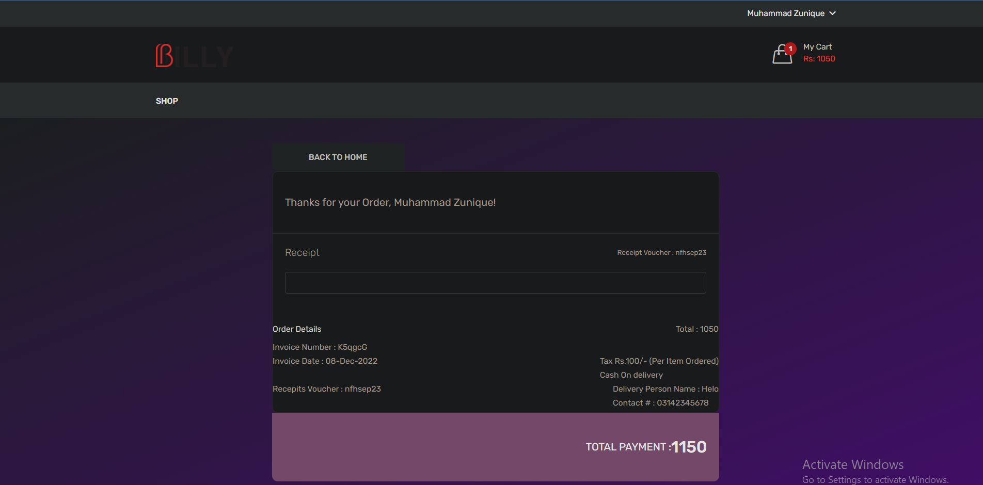

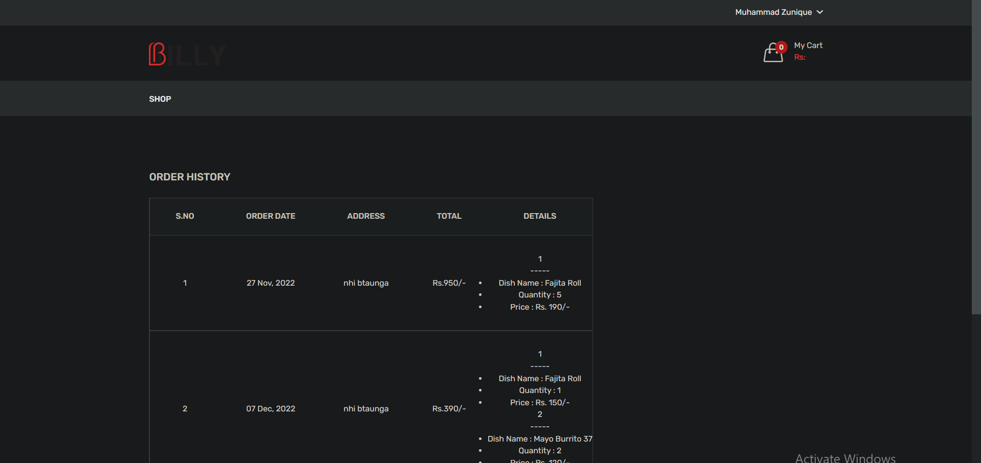

* **Delivery Boy Panel**

